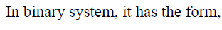

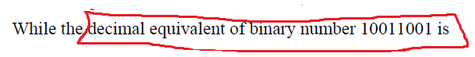

Take exponent of 2 from left to right (0 to –ve number)

= 1*1 + 0 + 0 + 1 / 8 + 1 / 16 + 0 + 0 + 1 / 128

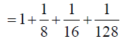
Calculate the above fractions values into decimal

