Mass or Weight?
Click here for audio and Spanish translation

How much does this bag of sugar weigh?
What is the weight of the sugar inside the bag in the picture? If you answer the question by saying 1 kilogram, you would be wrong! You see, kilograms and grams are units of mass, not weight. Weight is measured in units called newtons. Confused by the difference between mass and weight? Why do we need different units?
We have already discussed that mass is a measure of the amount of matter in an object. The bag contains sugar with a mass of 1 kilogram. Weight is quite different from mass. It is a measure of the force of gravity. Gravity is the force of attraction between two objects. Earth and the sugar are attracted to each other. This attraction varies with the size of the two objects and their distance apart. The force of attraction between a mass of 1 kilogram and Earth is about 9.8 newtons. So the answer to the question “How much does the sugar in this bag weigh?” is 9.8 newtons.
If an astronaut took the bag of sugar to the moon, what would be its mass? Would it contain the same amount of matter? The answer is yes. Provided the astronaut hasn’t eaten or dropped any of the sugar, the bag would still contain sugar with a mass of 1 kilogram. What is the weight of the bag of sugar on the moon? The moon is much smaller than Earth, so the force of attraction between the sugar and the moon is less. Gravity on the moon is about one-sixth of that on Earth. So what is the weight of sugar on the moon? Divide 9.8 newtons by 6 and you’ll get an approximate answer.

QUESTION
How would the weight of the same bag of sugar on Mars and Jupiter differ from that on Earth? Explain your answer.

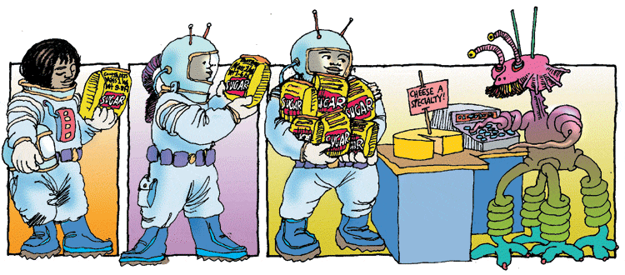
When it comes to mass, it doesn't matter where you are because the mass of an object is always the same. But if you are buying something by weight, you will get a lot more for the same cost if you buy it on the moon!

