**Lesson 11**

**KACHRU’S THREE CIRCLE-MODEL OF WORLD ENGLISH**

**Topics:**

* **The inner circle**
* **The outer circle**
* **The expanding circle**
* **Institutionalization of English**

**The Three Circles**

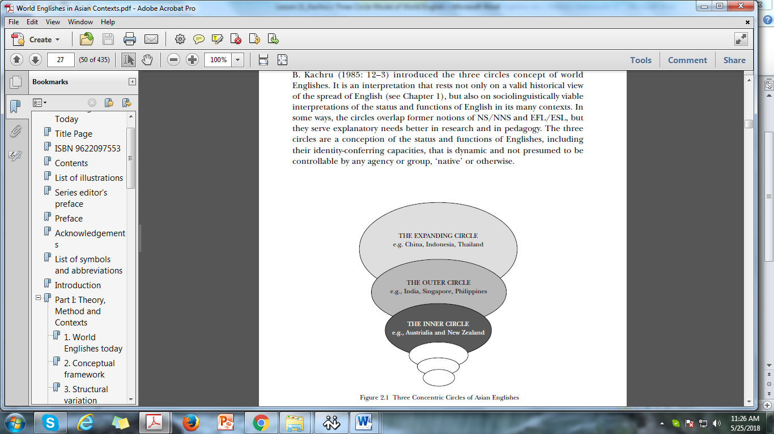

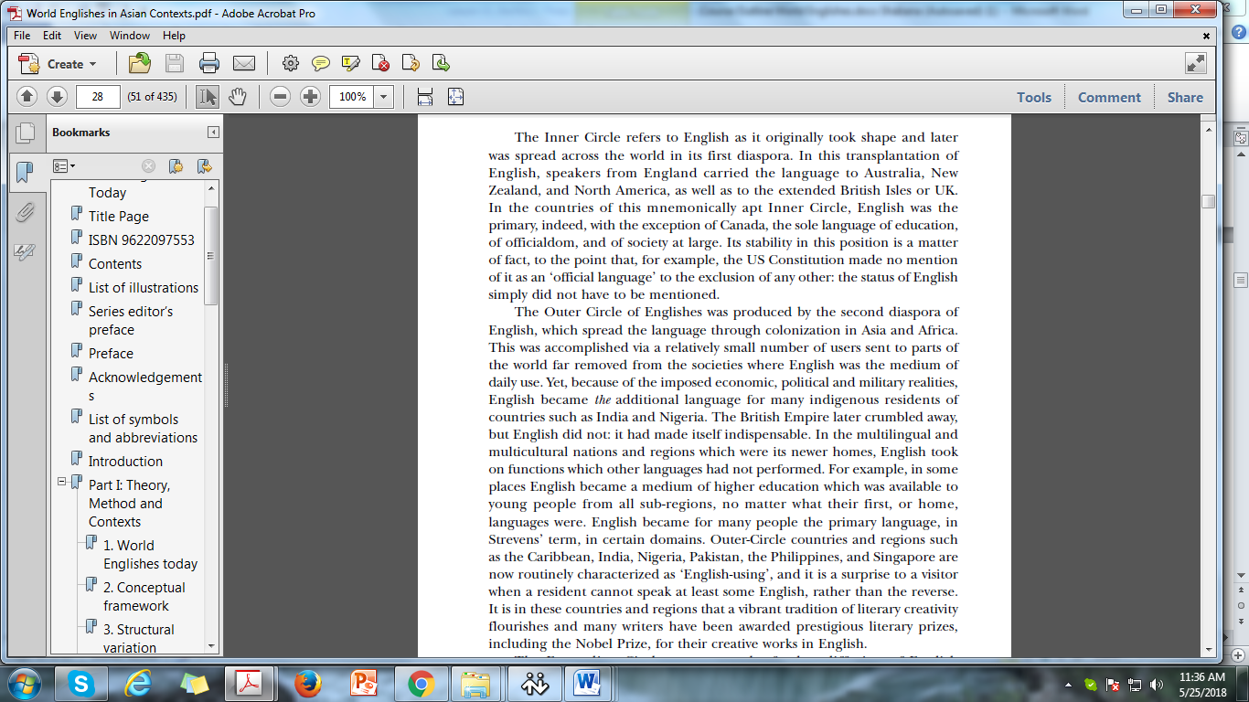

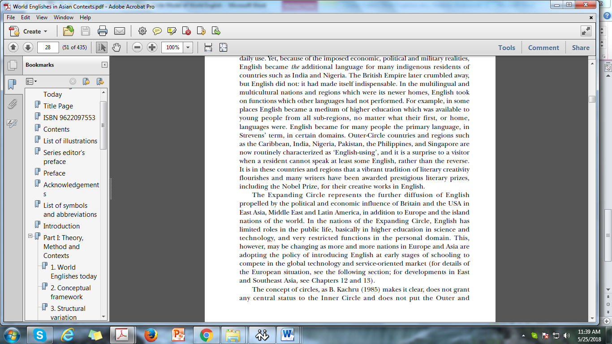

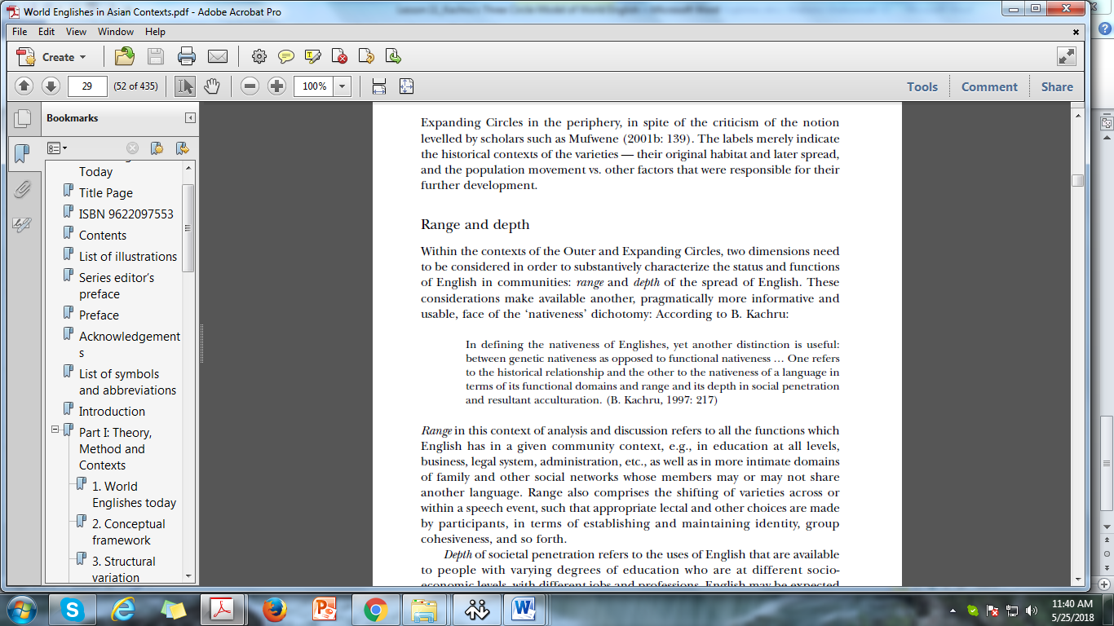

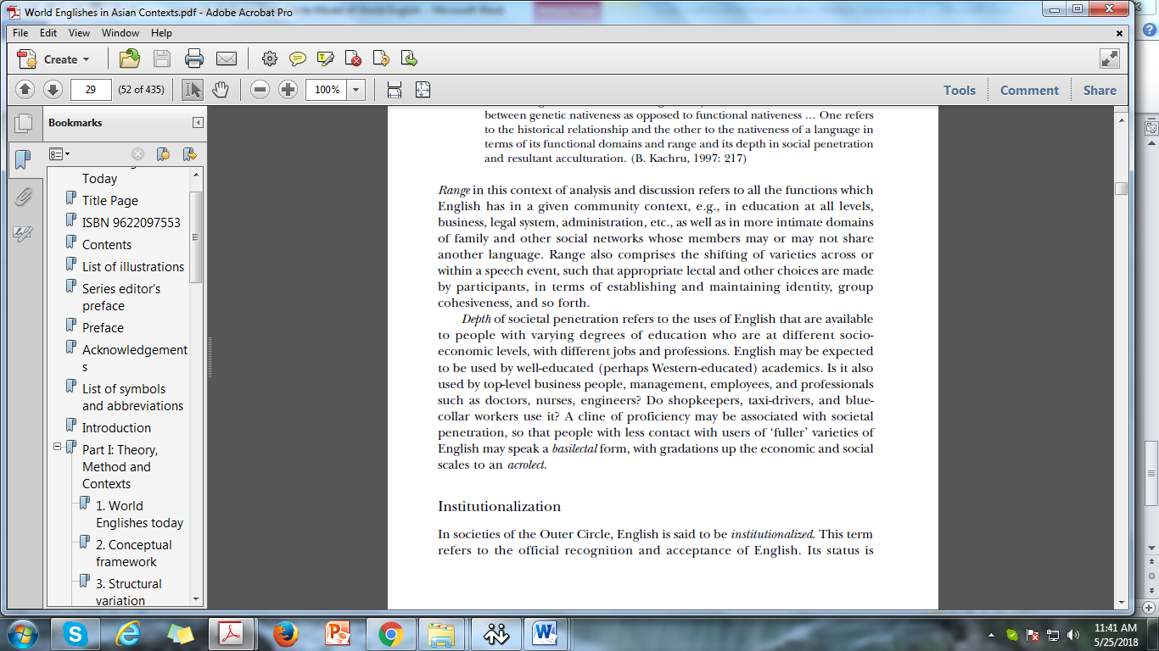

**Topic**

* **Status and functions of English in the outer and expanding circle**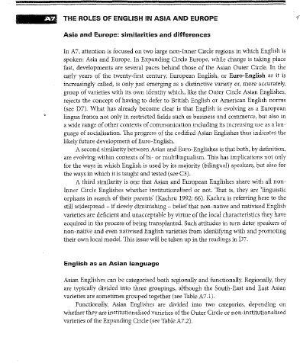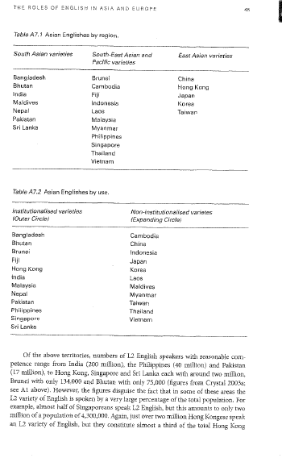

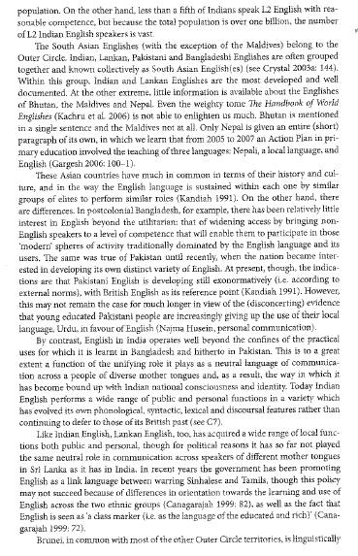

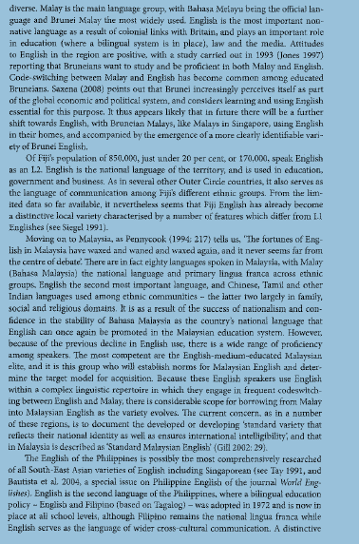

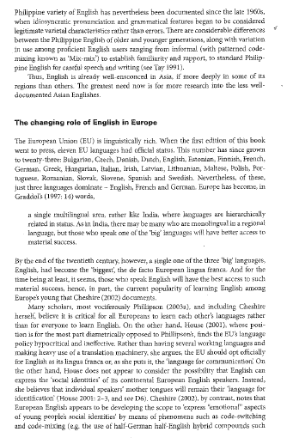

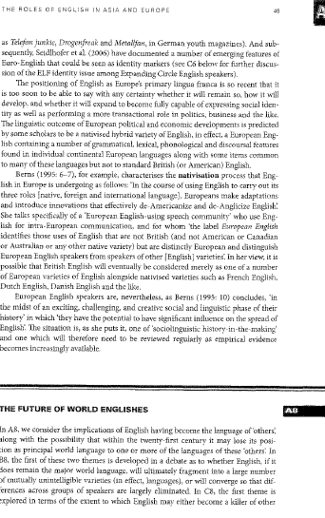

**Topic:**

* **Norm Providing, Norm Developing and Norm Dependent**

A way of seeing the categorization of the circles is in terms of where the norms for the communities come from. In Expanding-Circle countries, as has been mentioned, the norms still come from outside, from the Inner Circle. This is basically true of China, Japan, Thailand and Korea in Asia and in most of the countries in the Middle East, a large part of Europe and Latin America. Thus, the Inner-Circle Englishes may be spoken of as ‘norm-providing’ — they

provide norms and, less abstractly, teaching models and physical materials such as textbooks — to the Expanding Circle, which may then be termed ‘normaccepting’. This is the situation in Korea, for example, where US English is considered the prestige model (see Baik and Shim, 1995); cf. Cheng’s (1992) remarks on the Chinese switch from British to American English as the target of teaching and learning. Historically, British and American English have been

the two prestige models, but the situation is ‘dynamic’, as B. Kachru (1997: 220) terms it: exposure to various Englishes is becoming technologically easier, and ‘variational pluralism’ is taking hold in some contexts (e.g., the codification of Australian English, as discussed by Butler, 1997). In the Outer Circle, the situation regarding norms is more complicated;

attitudes having to do with cultural and political identities make themselves felt, with some spokespersons advocating outright banishment of English, others, adoption of one or another Inner-Circle model, and still others, adoption of a regional or local model. This is the ambivalent situation that B. Kachru terms ‘norm-developing’ and applies to many countries in South Asia and Southeast Asia. Although attitudes vary and debates continue, the English language is going through the natural processes of nativization of sounds, vocabulary, grammar and conventions of using language to perform various acts. The nativized variety is what is being used in everyday life, in media, and in other domains of national life. Along with the process of nativization of English, the process of English influencing the local languages continues, which has been termed ‘Englishization’ (B. Kachru, 1979).

**References:**

**Compiled from**

* **Kachru, Y. & Nelson, C. L. (2006). *World Englishes in Asian contexts*. Hong Kong University Press: Hong Kong.pp27-30**
* **Jenkins, J. (2009). World Englishes: A resource book for students. (2nd Ed.). Routledge: London. pp 44-49**