**Corrigendum of Lecture No. 07**

**Dear Students of ECO404/704!**

This is to inform you that in topic of “Simple linear demand curve estimation” in lecture No.07, values of prices in following both equations are mistakenly wrong.

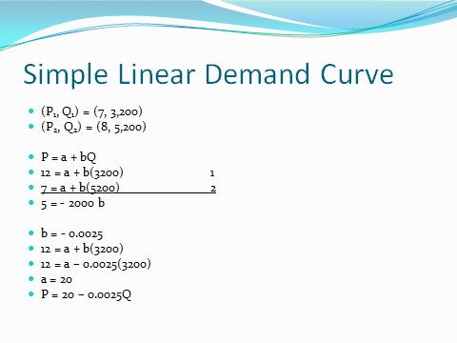

Correct values are as follows:

(P1, Q1) = (12, 3,200)

(P2, Q2) = (7, 5,200)

**Wish you best of luck for the whole semester!**