**Step 1: Go to settings**

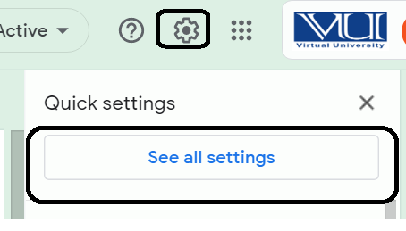

**Step 2: Go to filters then click on Create a new filter**

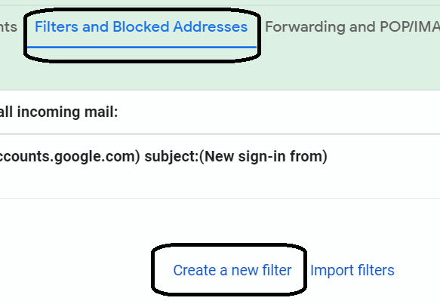

**Step 3: Enter VU’s domain: @vu.edu.pk in From text box, and proceed next step by clicking Create Filter:**

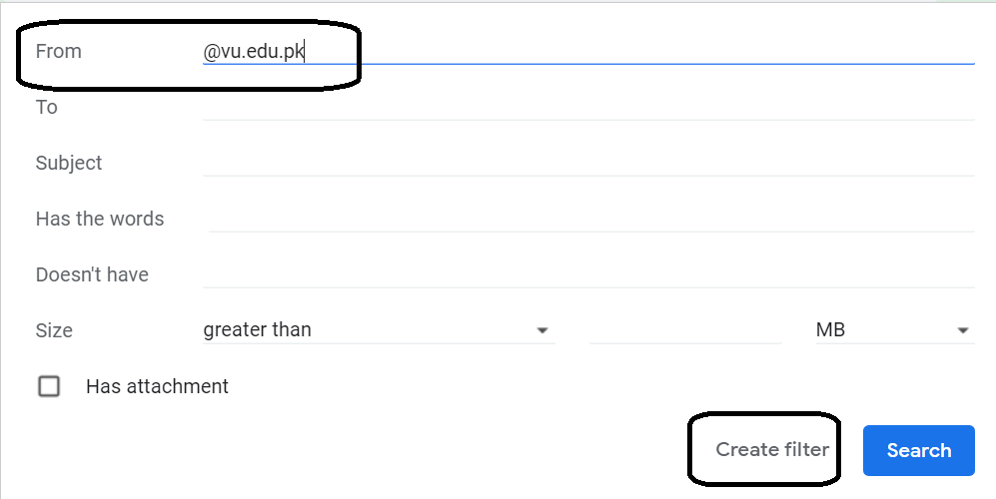

**Step 4: Check ‘Never send it to Spam’ and click on Crate filter button to finish:**

