**Lab 15: Calculating Bit Map Overhead in Disk Free-Space Management in C**

Write a c program to calculate the Overhead of Bit Map (or Bit Vector) in Free-Space Management. Frequently, the free space list is implemented as a bit map or bit vector. Each block is represented by 1 bit. If the block is free, the bit is 1;if it is allocated, the bit is 0. This approach is relatively simple and efficient in finding the first free block or n consecutive free blocks on the disk.

The output of program is as shown below:

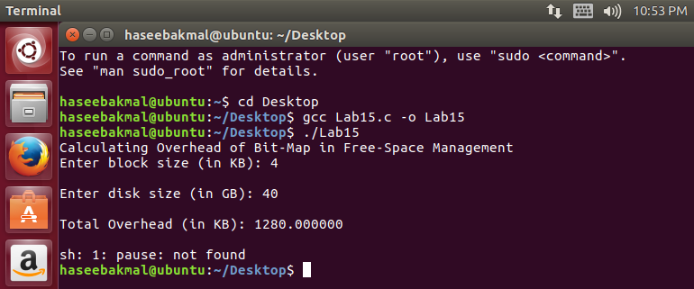

#include<stdlib.h>

#include <stdio.h>

int main()

{

double blockSize, diskSize, overhead;

printf("Calculating Overhead of Bit-Map in Free-Space Management");

printf("\nEnter block size (in KB): ");

scanf("%lf", &blockSize);

printf("\nEnter disk size (in GB): ");

scanf("%lf", &diskSize);

diskSize = diskSize*1024*1024;

overhead = (diskSize / blockSize)/(8*1024);

printf("\nTotal Overhead (in KB): %lf", overhead);

printf("\n\n");

system("pause");

}