**Learning Management System  
http://vulms.vu.edu.pk**

Teams Discussion Board (Student Section)

Overview and Processes Flow

Version 1.0.0

Table of Contents

**What This Document Contains?** 3

**Major Features of TDB Module** 4

**Process Flow of TDB Module** 5

**Interfaces Introduction (Usage Guide)** 6

• Entering in TDB Module 6

• Joining Topic 7

• Viewing Only Joined Topics 8

• Creating Thread 9

• Viewing Threads List 11

• Viewing replies on Threads 12

• Posting Comments on Threads 13

**W****hat This Document Contains?**

This document is structured to explain newly developed Teams Discussion Board module (Students Section) in LMS along with its major components and processes flow. It also introduces Teams Discussion Board interfaces for student by using screen shots. This document is intended to provide overall details of this newly developed module.

**M****ajor Features of TDB Module**

* Discussion Topics

Joining a Topic

Viewing Total Participants, Total Threads, Start Date, Time and Status

* Threads Management

Creating Threads

Filtering Own Threads

Sorting by Student ID or Post Date

Filtering on Thread’s creator, Create Date and Total posts

* Comments Management

Posting Comments

Viewing Replies or Comments

**P****rocess Flow of TDB Module**

**Interfaces Introduction (Usage Guide)**

## Entering in TDB Module

* 1. Click on **TDB** link in LMS Home page as shown in Figure 1.1.
  2. Discussion Topics list will be opened as shown in Figure 1.2.

**Note:** TDB link will only enabled by administrator section.

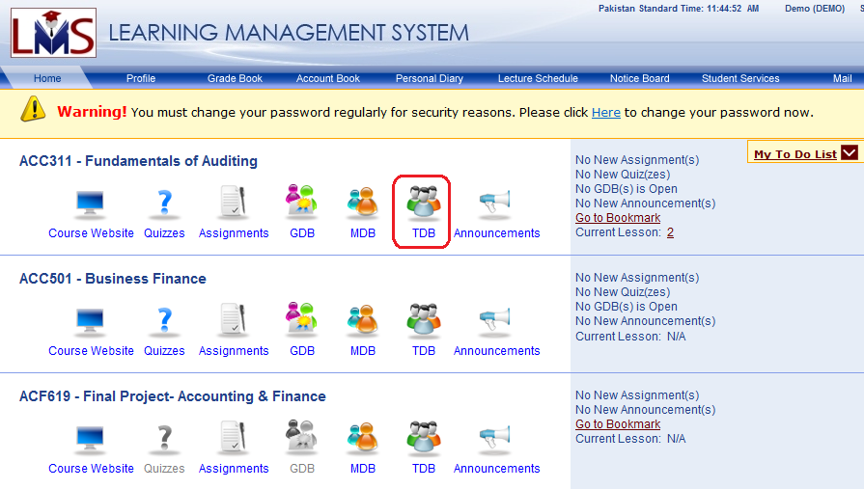

Figure 1.1

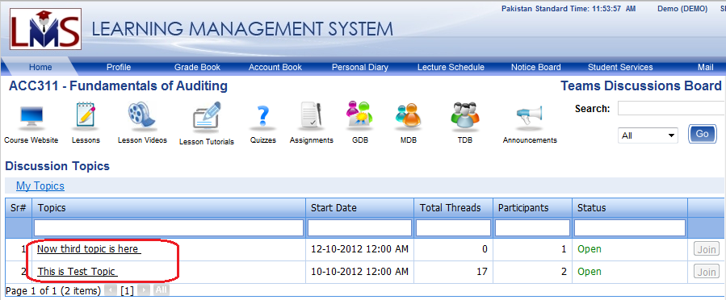

Figure 1.2

## Joining Topic

***Note:*** *Student has to join the Topic in order to create thread and post reply to any thread.*

* 1. Click on **TDB** link as shown in Figure 1.1.
  2. In Discussion Topics Page, click on **Join** button in desired Topic’s row as shown in Figure 2.1. After successful joining, **Join** button will be disabled. (*Join button will be disabled for already joined Topics*).

**Note:** If you have any already join topics in list then **My Topics** link will be visible on top left side as shown in Figure 3.1.

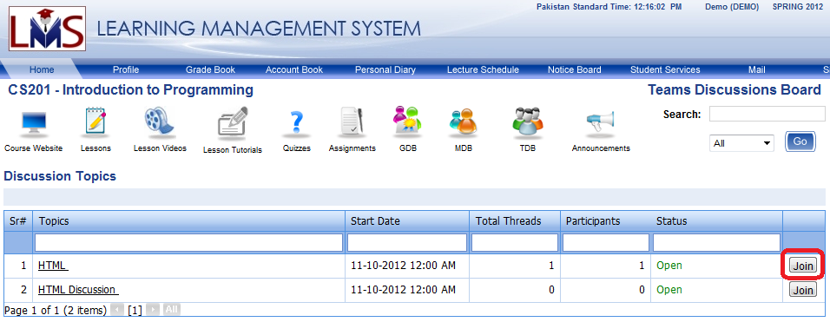

Figure 2.1

## Viewing Only Joined Topics

***Note:*** *By default; All Topics will be available to view*

* 1. Click on **TDB** link as shown in Figure 1.1.
  2. In Discussion Topics Page, click on **My Topics** button on top left side of page as shown in Figure 3.1. (*After clicking, link will be changed to* ***Show All Topics*** *as shown in Figure 3.2*).

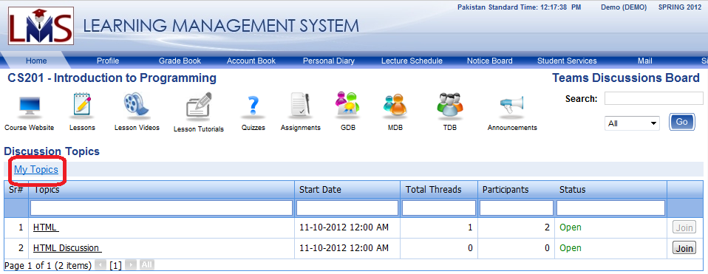

Figure 3.1

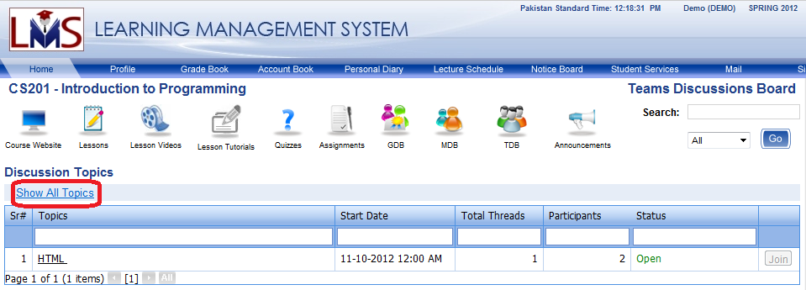

Figure 3.2

## Creating Thread

* 1. Click on the desired Topic in Discussion Topic page as shown in Figure 4.1.
  2. In opened page, all available threads of selected Topic are viewable as shown in Figure 4.2.
  3. Click on **Create New Thread** link available on top of threads list as shown in Figure 4.3
  4. A new window will be opened for entering details as shown in Figure 4.4. Enter thread details and Click on **Post** button to save it. After save newly created thread will be list down in page as shown in Figure 4.5.



Figure 4.1

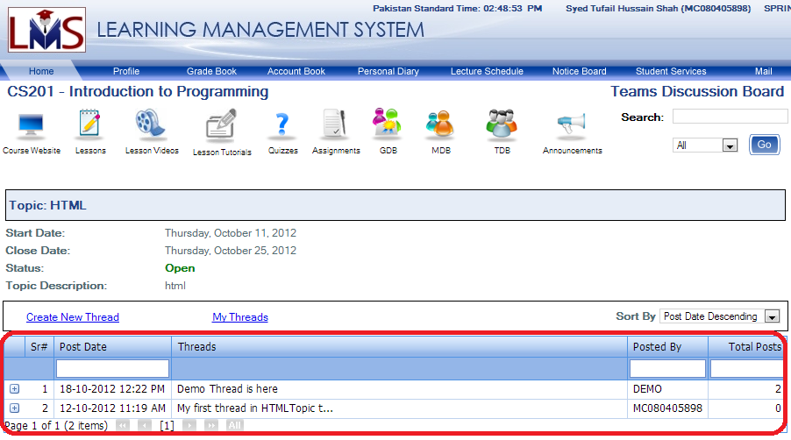

Figure 4.2

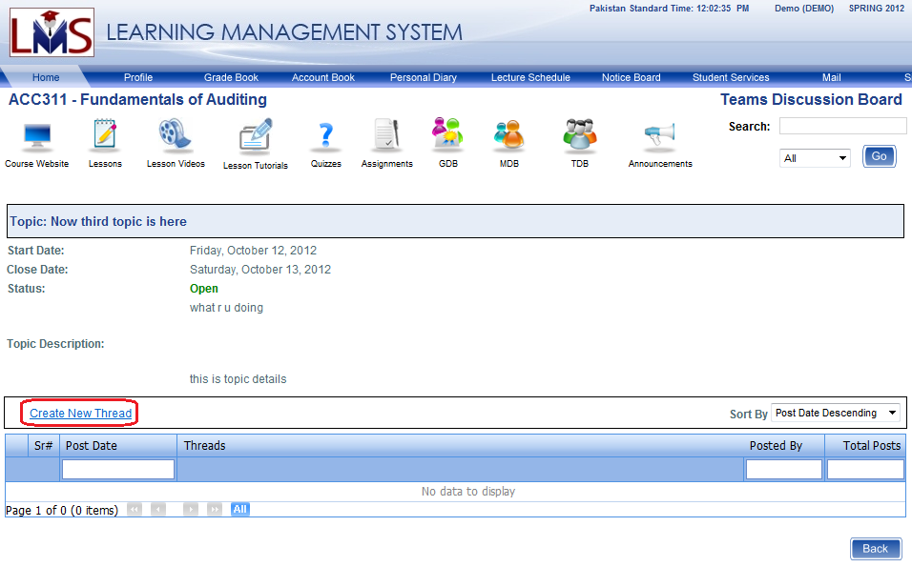

Figure .3

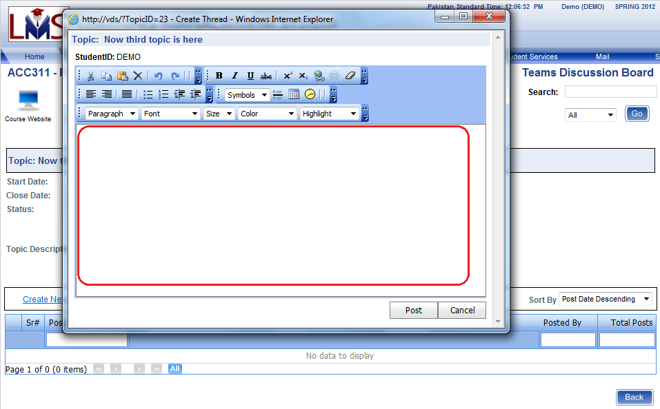

Figure 4.4



Figure 4.5

## Viewing Threads List

1. Click on the desired Topic in Discussion Topic page as shown in Figure 5.1.
2. In opened page, all available threads of selected Topic are viewable as shown in Figure 5.2.



Figure 5.1



Figure 5.2

## Viewing replies on Threads

1. Click on the desired Topic in Discussion Topic page as shown in Figure 5.1.
2. In opened page, all available threads of selected Topic are viewable as shown in Figure 5.2.
3. Click on expand (**+**) button as shown in Figure 6.1.
4. All discussion will be displayed as callouts as shown in Figure 6.2.

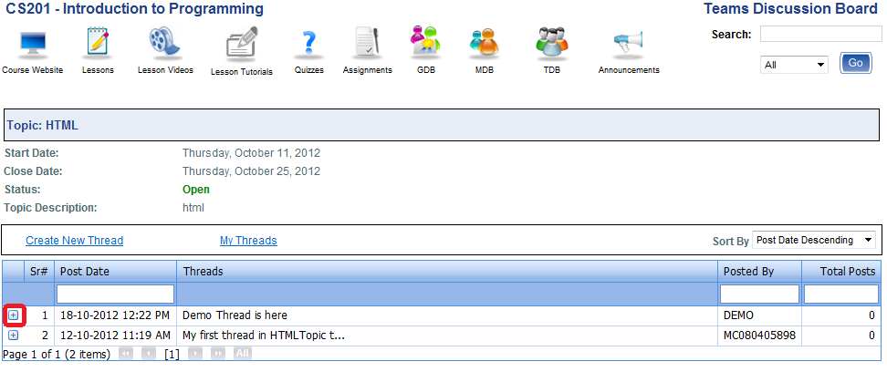

Figure 6.1

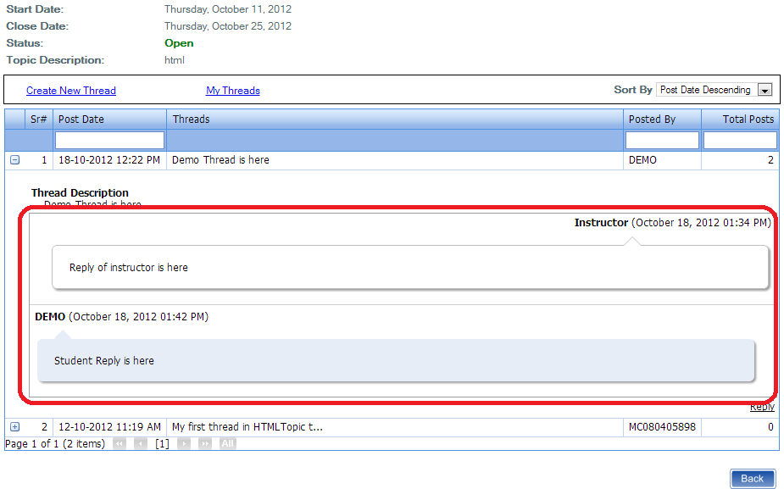

Figure 6.2

## Posting Comments on Threads

1. In **Threads** page, expand thread by clicking on expand (**+**) button as shown in Figure 7.1.
2. Click on the **Post Comments** link as shown in Figure 7.2.
3. Enter comments in appeared Rich Text Box as shown in Figure 7.3.
4. Click on **Post Comments** button to save as shown in Figure 7.3.
5. The saved comments will appear under thread as shown in Figure 7.4.



Figure 7.1

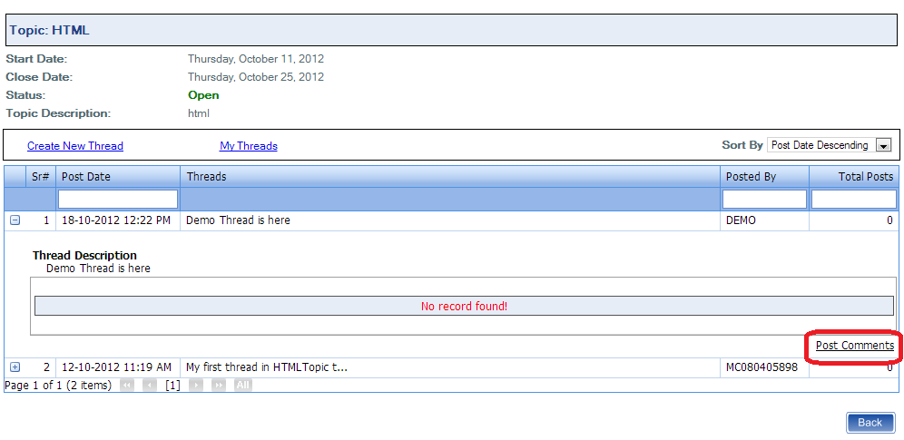

Figure 7.2

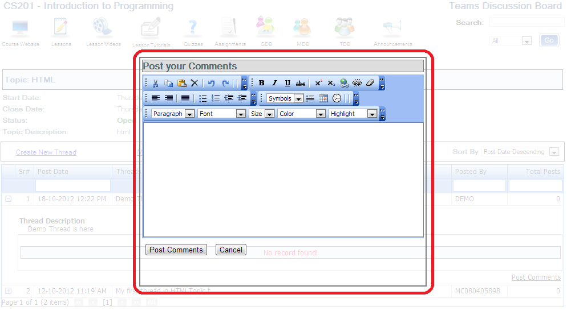

Figure 7.3



Figure 7.4