 | Assignment No. 02  Semester: Spring 2009  IT430 E-Commerce |  | Total Marks: 20  Due Date:14/04/2009
Instructions
Please read the following instructions carefully before submitting assignment:
It should be clear that your assignment will not get any credit if:

- The assignment is submitted after due date.
- The submitted assignment does not open or file is corrupt.
- The assignment is copied.
- If HTML Code is sent in Word file.

Objective

The objective of this assignment is to provide hands on experience of HTML specially Forms and JavaScript.

Assignment
Question: [20 Marks]

You are required to make an HTML page , That page will contain a FORM as shown below in Figure 1

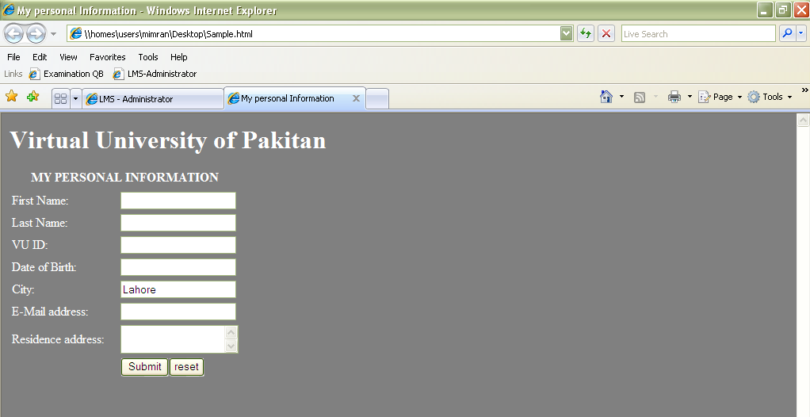

Figure 1

Important notes about the above page,

- When the page opens all the fields are blank. Except City field, which will have the Name of your City by default.

- Fields First Name and Last Name both have max length of 10. i.e. form will not allow you to enter more then 10 character in it.

- The Maximum length of VU ID field is 11. i.e. form will not allow you to enter more the 11 character in it.

Checks to be performed using java script.

As soon as you will move your mouse pointer over the Submit Button,

1)
If the First Name is empty it will display a message First Name Filed is empty , like

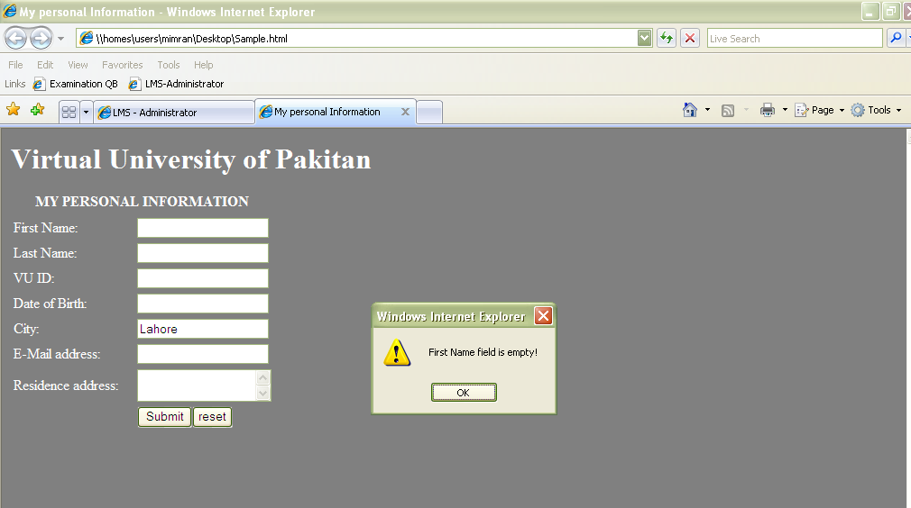

2) If the Last Name is empty it will display a message Last Name Filed is empty , like

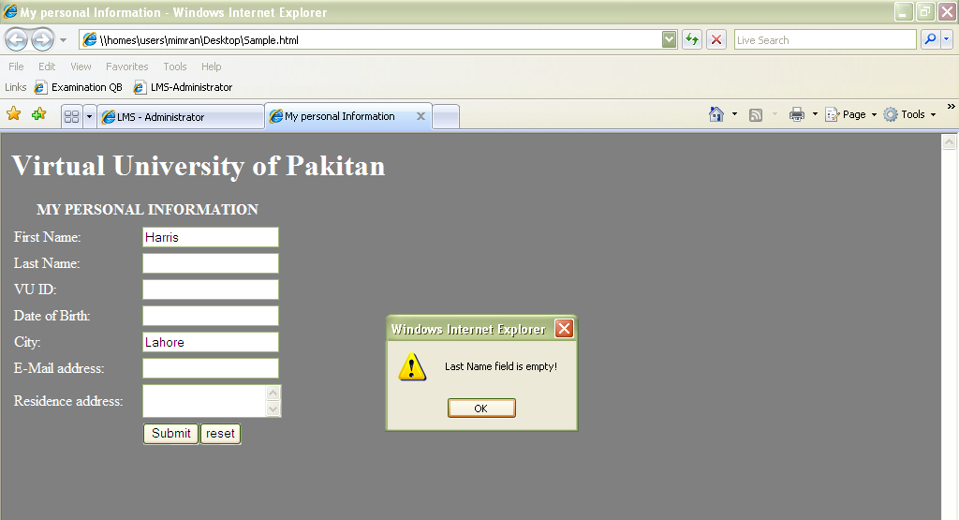

3) If the VU ID Field is empty it will display a message VU ID is empty , like

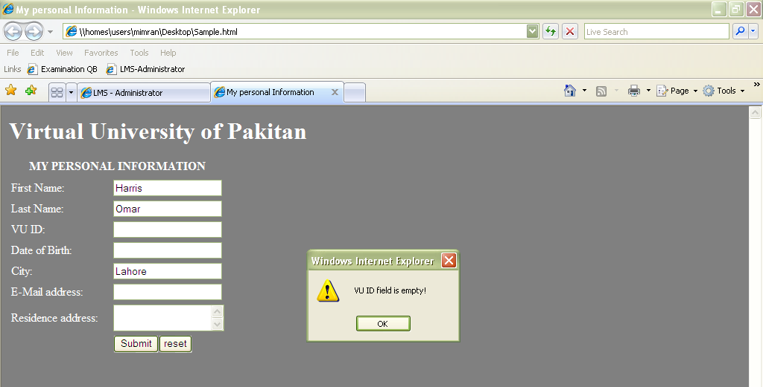

4) Date of Birth, Email Address and Address can be empty.

4) You will submit form to http://www.vu.edu.pk.

Hints:

Read and explore about maxlength in HTML.
Read and explore onmouseover event in JavaScript

Deadline:
Your assignment must be uploaded/submitted on or before 14th April 2009.
You will submit/upload HTML file.

